COA T2 Practice Examples

Problem 1: Execution times of hardware blocks of a single cycle datapath are as follows:

Multiplexer 1ps

Control 3ps

Register file read or write 15ps

Sign extension 1ps

Shift left by 2 1ps

Adder or ALU 25ps

Instruction/data memory read or write 20ps

All other hardware times can be neglected. Find a lower bound on the cycle time for the program counter.

Answer:

The critical path is exercised by the lw instruction. This instruction is executed as follows [items in brackets are concurrent with the previous item but take less time and therefore do not affect the critical path]:

Operation Hardware used Time required

Instruction fetch Instruction memory 20ps

[Adder, PC+4] [Adder is not in critical path] [25ps]

Register read register file 15ps

[Immediate argument] [(control or sign ext.) + multiplexer] [4ps]

Address computation ALU 25ps

Data memory read Data memory 20ps

Write register multiplexer + reg. file 16ps

Total time 96ps

The clock cycle time for PC must not be less than 96ps.

Problem 2: Consider the hardware times of major units (others being negligible) in a datapath as:

Memory access (read or write) 50ps

ALU 75ps

Register file (read or write) 50ps

Determine minimum clock cycle time, average CPI, and average instruction execution time for single-cycle and multi-cycle datapaths for the following program statistics:

Instruction type | Percentage in the program | Clock cycles used by instruction
Instruction type | Percentage in the program | Single-cycle | Multi-cycle
lw | 10 | 1 | 5
sw | 10 | 1 | 4
branch | 20 | 1 | 3
jump | 20 | 1 | 2
register | 40 | 1 | 4

Answer:

Single-cycle clock period (cycle time) is determined by the lw instruction, which activates the critical path:

Cycle time = memory + reg. file + ALU + memory + reg. file

= 50 + 50 + 75 + 50 + 50 = 275ps

Av. CPI = 1

Av. time/instruction = 275 ✕ 1 = 275ps

Multi-cycle clock period (cycle time) is determined by the slowest hardware unit (ALU):

Cycle time = 75ps

Av. CPI = 0.1✕5 + 0.1✕4 + 0.2✕3 + 0.2✕2 + 0.4✕4 = 3.5

Av. time/instruction = 75 ✕ 3.5 = 262.5ps

Problem 3:

- Suppose operations involving register file, memory or ALU take 1 time unit each. Neglecting the time of all other hardware, how much time will each MIPS instruction take on a single-cycle datapath? Consider R-type, lw, sw, beq and j instructions.
- What will be the execution times for MIPS instructions on a 5-cycle multi-cycle datapath using a clock period of 1 time unit?
- A program contains the following mix of instructions:

lw 15%

sw 10%

R-type 45%

Branch 20%

Jump 10%

What is the single-cycle CPU time to multicycle CPU time ratio for running this program on the two datapaths?

Answer:
- Each instruction will take 5 units of time on a single-cycle datapath.

- Times for MIPS instructions to run on a multi-cycle datapath are:

Load, lw 5 time units

Store, sw 4 time units

R-type, add, etc. 4 time units

Branch, beq 3 time units

Jump, j 3 time units

Single-cycle (cycles per instruction × cycle time)
- CPU time ratio = ——————————————————————

Multicycle (average cycles per instruction × cycle time)

1 × 5

= ———————————————————

(0.15×5 + 0.1×4 + 0.45×4 + 0.2×3 + 0.1×3) ×1

= (1 × 5) /(3.85 ×1) = 1.2987

Problem 4: Consider two types of MIPS datapaths. The clock rates for single-cycle and multicycle implementations are 250MHz and 1GHz, respectively. The following subroutine is used for estimating the performances. The argument register $a0 contains a very large positive integer (assume several million):

repeat addi $a0, $a0, –1
bne $a0, $zero, repeat
add $v0, $a0, $zero

Determine:
(a) Average cycles per instruction (CPI) for two datapaths.
(b) How much faster is the multicycle execution of the program (ratio of single-cycle to multicycle execution times)?
Answer:
(a) Single-cycle CPI = 1.0, because each instruction executes in one cycle.

The instruction mix for multicycle datapath is:

addi takes 4 cycles and is executed a0 times
bne takes 3 cycles and is executed a0 times.
add takes 4 cycles and is executed once (neglected)

Total number of instructions = 2a0 + 1 ≈ 2a0

Multicycle CPI = (4×a0 + 3×a0)/(2a0) = 7/2 = 3.5

(b) The multicycle clock period is 1ns and the single-cycle clock period is 4ns. Therefore,

Performance ratio = (single-cycle time)/(multicycle time)
= (4×2a0)/(1×3.5×2a0)
= 1.143

Problem 5: Modify the single-cycle datapath to implement the jalr instruction. State clearly whether you would like to make this an R-type instruction (destination register $rd, two source registers $rs and $rt) or an I-type instruction (destination register $rt, one source register $rs, one 16-bit signed immediate). Also be sure to specify the value of the control signals, plus any new control signals you might add.

Answer:
We could make this instruction either R-type (with the $rd ﬁeld set to $ra’s name) or an I-type (with rt set to $ra). In both cases, we will make $rs the register holding the address of the target function. The datapath should be changed as follows:
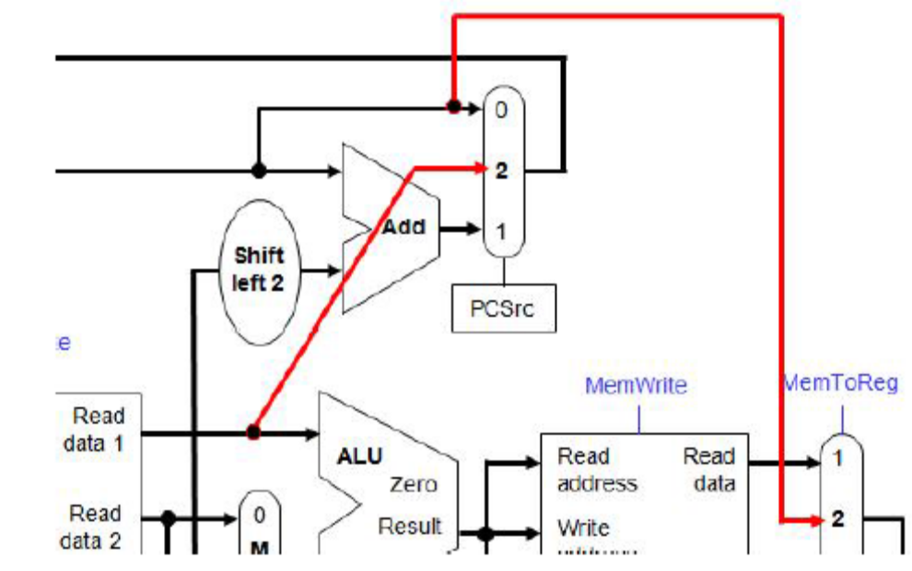
The control signals below are shown for the R-type variant. The I-type variant will be identical, except RegDst will be 0.

Note that ALUSrc and ALUOp are set to “don’t care” (X). As far as possible, control signals should be set to don’t care (to help minimize the control unit logic).
However note that MemRead and MemeWrite must be set to zero in this case: we don’t want to write to memory, and since we don’t know what the ALU output will be, we don’t want to read from a potentially invalid memory address.

Note that by making ALUOp “don’t care”, there is a possibility that the ALU operation could cause an exception (e.g., divide-by-zero). If this happens, we would have to select some “safe” operation for ALUOp instead.

